Name:___________________________________________________________Date:_________________Block:_______

**Advanced Geometry Review – Chapter 2**

**Using Inductive Reasoning (Patterns) and Deductive Reasoning (Facts, Logic)**

1. What is the next item in the pattern: 1, -3, 9, -27, ....
2. Use inductive reasoning to make a conjecture about the product of two odd numbers.
3. Use inductive reasoning to make a conjecture about the sum of two odd numbers.
4. Give a counterexample to show that the following is false: "If  and are complementary, then the angles are not congruent."
5. Give a counterexample to show that the following is false: "If  and are congruent, then they are both obtuse angles."
6. Give a counter example to show that the following is false: If an angle is acute, then it has a measure of 30°.
7. Use the statements below to answer parts a and b.

If you are a member of the swim team, then you practice on Saturdays. If you practice on Saturdays, then you have a special pass to get into the pool.

1. Using Law of Detachment, write a conjecture for the following statement:

Sue practices with the swim team on Saturdays.

Conjecture:

1. Write a new conditional statement using the Law of Syllogism.

**Conditional Statements**

1. Write a conditional statement for each Venn Diagram.

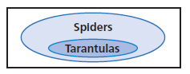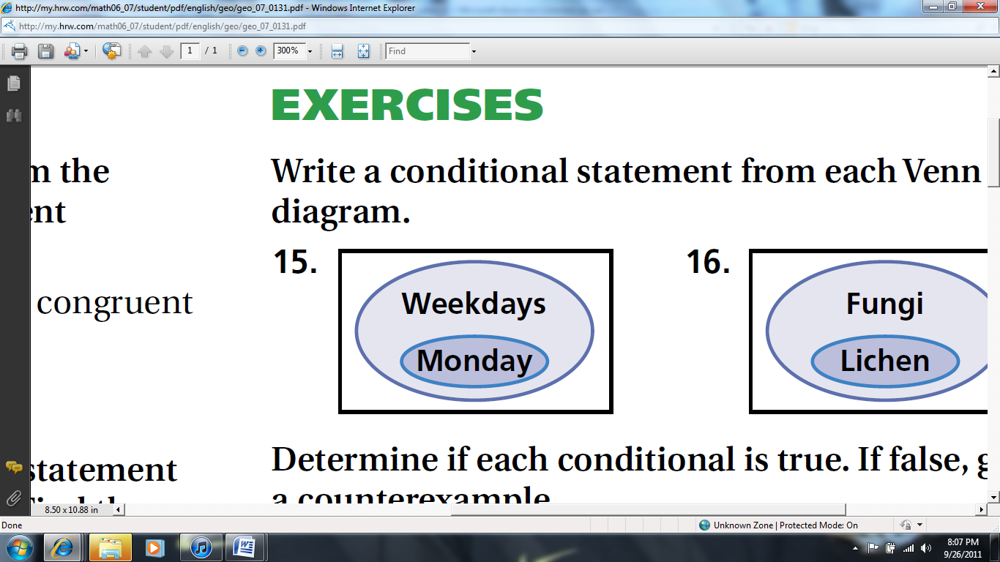

1. Write the converse, inverse, and contrapositive. Determine if each statement is true or false.

" If you live in Oklahoma, then you live in the United States."

Converse: _________________________________________________________________________T or F

Inverse: ___________________________________________________________________________T or F

Contrapositive: _____________________________________________________________________T or F

1. Draw a Venn Diagram to illustrate the following conditional statements:

If an animal is a blue jay or a cardinal, then it is a bird.

If an animal is a dog, then it is a mammal.

1. Write the following statements as biconditional statements.

a. The measure of a right angle is 90°.

b. If this month is September, then next month is October.

**Proofs about Angles and Segments**

1. Write a two-column proof

Given: $\vec{BD}$ bisects $∠ABC.$ $m∠ABD=(3x+25)°$ and $m∠BDC=(7x+5)°$

Prove: $m∠ABD=40°$

1. 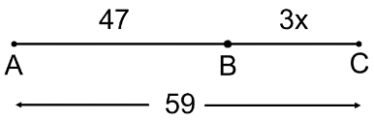Given: B is between A and C.

Prove: x = 4

1. Identify the property that justifies each statement.

_____ a. 25 = 25 A. Transitive Property of Congruence

_____ b . If then  B. Symmetric Property of Congruence

_____ c. 2x = 9, and y = 9, so 2x = y. C. Reflexive Property of Congruence

_____ d.  D. Division Property of Equality

_____ e. If x = y, then x + 5 = y + 5 E. Mult. Property of Equality

_____ f. If x = y, then 2x = 2y. F. Subtraction Property of Equality

_____ g. 3(x + y) = 3x + 3y G. Addition Property of Equality

_____ h. If x = y, then y = x. H. Distributive Property

_____ i. If x = y, then $\frac{x}{w}=\frac{y}{w}$. I. Substitution Property of Equality

_____j. If x = y, then x - 7 = x - 7 J. Transitive Property of Equality

K. Symmetric Property of Equality

L. Reflexive Property of Equality

1. Given:  and  complementary and .

Prove: $∠3 and ∠2$ are complementary.

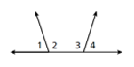

1. Given: $m∠1+m∠3=180°$

Prove: $∠1≅∠4$

|  |  |
| --- | --- |
| **Statements** | **Reasons** |
| 1. $m∠1+m∠3=180$ | 1. |
| 2. | 2. Definition of Supplementary Angles |
| 3. $∠3$ and $∠4$ are supplementary | 3. |
| 4. $∠3≅∠3$ | 4. |
| 5. | 5. Congruent Supplements Thm. |

1. 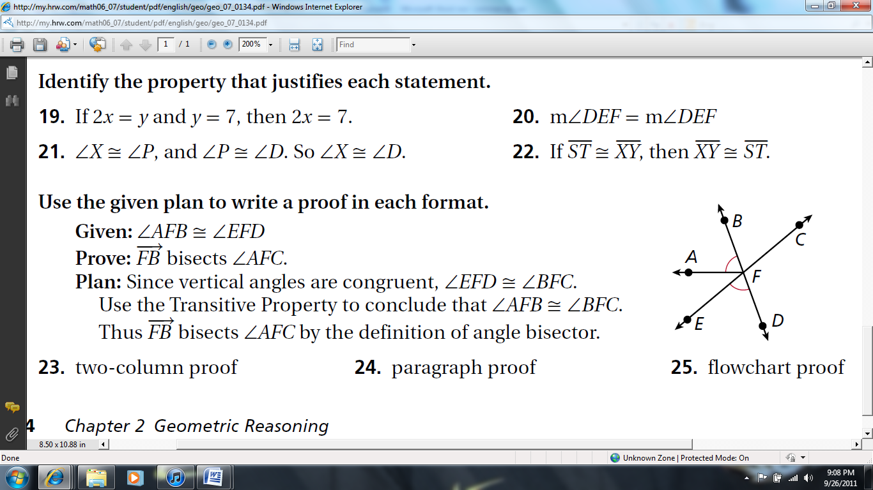Given: $∠AFB≅∠EFD$

Prove: $\vec{FB}$ bisects $∠AFC$

1. 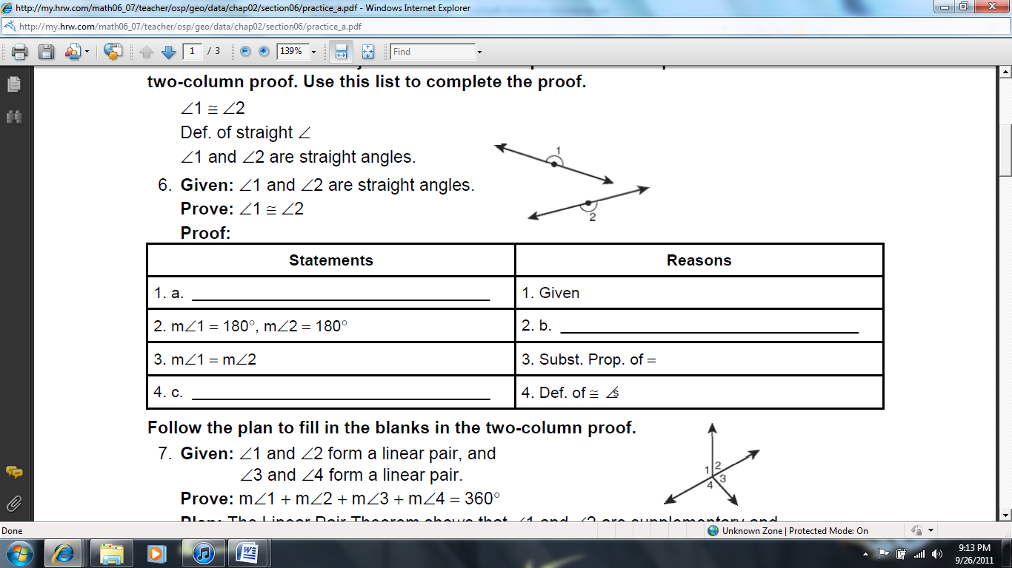Given: $∠1$ and $∠2$ are straight angles.

Prove: $∠1 ≅ ∠2$