Algebra 1
WS PC #1 Review – Unit 2

Find the domain and range and determine if it is a function. Support your answer.

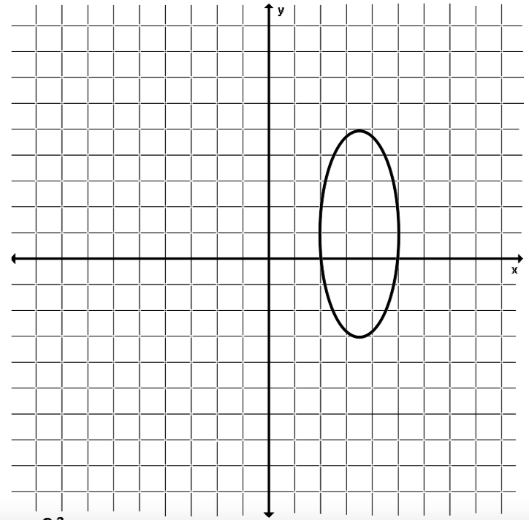
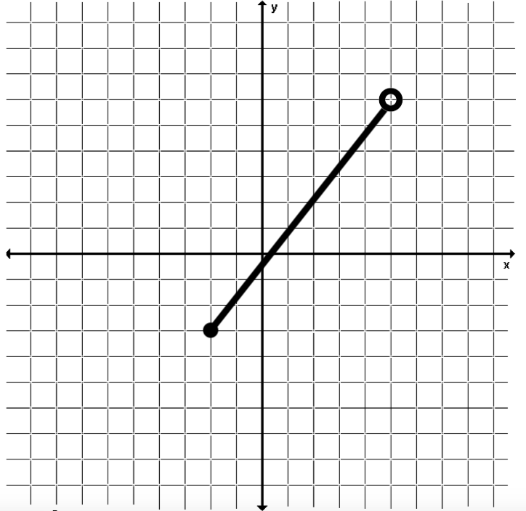
- 2.

D: D:

R: R:

Linear: Y or N Linear: Y or N

x | 2 | 1 | 0 | -1
y | 4 | 7 | 7 | 4
x | -3 | 4 | 0 | 4
y | 1 | 2 | 3 | 5
3. 4.

D: D:

R: R:

Linear: Y or N Linear: Y or N

5. Create a mapping for the following points and determine if it is a function. Support your answer.
{(-6, 8), (-2, 9), (0, 10), (-2, 11), ( -5, 12)}

Given $f\left(x\right)= 8-3x and g\left(x\right)={5+2x}^{2}$, find the following:
6. $f(-10)$ 7. $g(-1)$ 8. $f\left(0\right)- g(2)$

9. $3 g(7)$ 10. $g\left(-5\right)+ f(5)$ 11. $\frac{f(-4)}{5}$

Write the function and solve for the given information.

12. A personal trainer charges a set-up fee of $50 for new customers plus a fee for each hour. If it cost $230 for 12 hours of training, what is the fee for each hour?

13. Mrs. Roberts is going to get senior pictures taken of her daughter. She finds a photographer who charges $120 for the sitting fee and $15 for each pose. Write a function to represent the total cost of the pictures for x poses. If Mrs. Roberts paid $195 to the photographer, how many poses did they use?

Find the x- and y-intercepts of each function. Write the intercepts as an ordered pair. Then graph.

14. $3x-2y=12$ 15. $-6x-8y=16$ 16. $9y+3x=9$

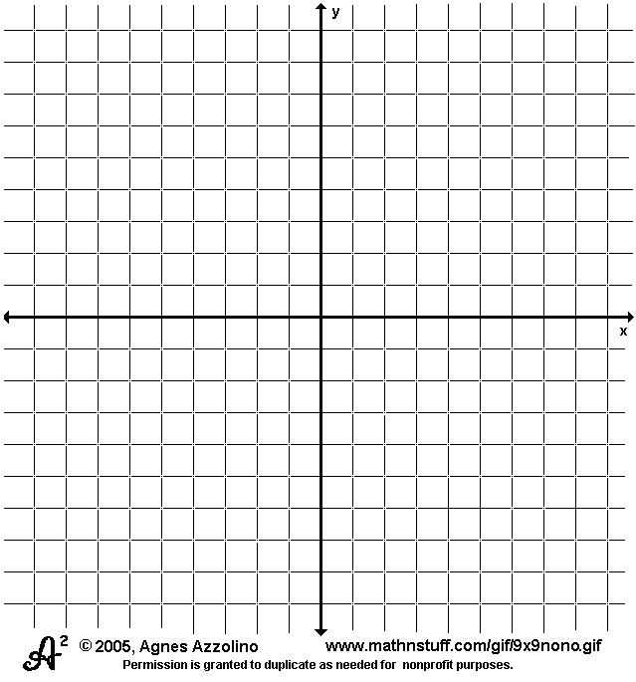

17. Solve each equation for y.
a. $5x-3y=-15$ b. $y-3=2(x-4)$ c. $\frac{1}{2}x-3y=12$

18. Solve each for the given variable.
a. Solve for a: $\frac{a-b}{c}=xy$ b. Solve for x: $b\left(x+y\right)=a-c$

19. Graph each function.
a. $y=-3x-1$ b. $y=\frac{2}{3}x+4$ c. $f\left(x\right)=-\frac{4}{3}x-5$

20. Simplify each.
a. $x^{3}y^{-5}⋅xy^{-1}$ b. ${(2x^{-2}y^{4})}^{-3}$ c. $\frac{x^{8}y^{-6}x^{3}}{{(x^{2}y^{-3})}^{4}}$

