Name:___________________________________________Date:_____________________Hour:_______

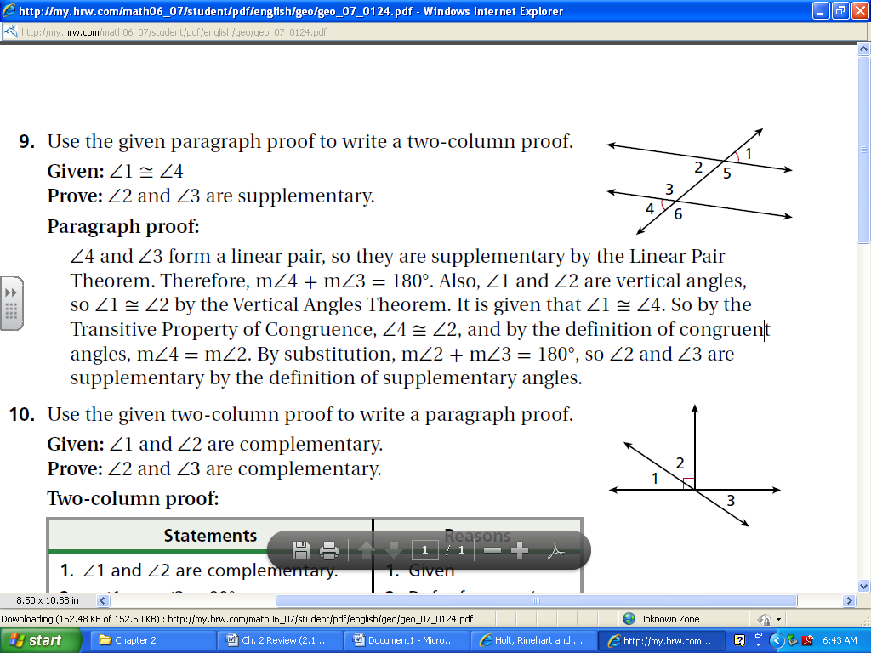**WS Geometric Proof 3**



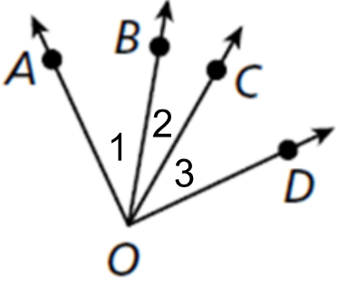

1. Given: $∠AOC ≅ ∠BOD$

Prove:

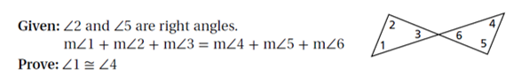

1. 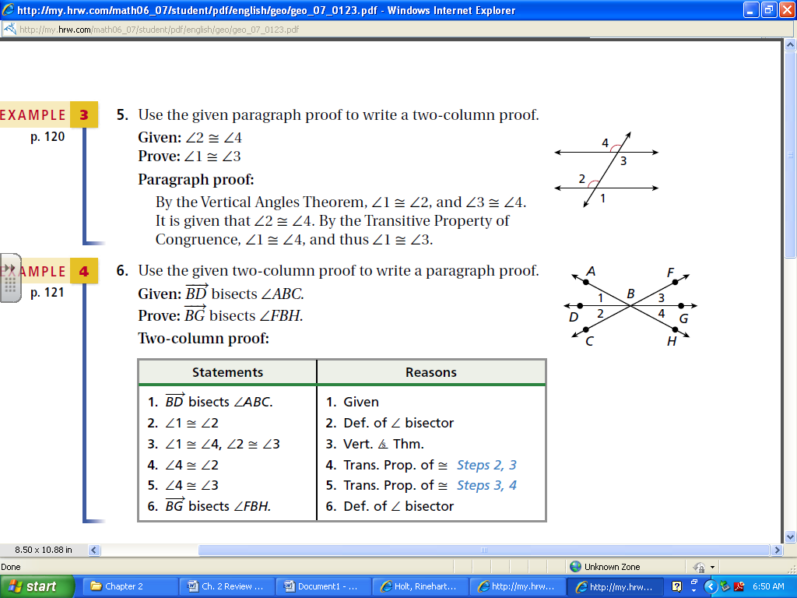

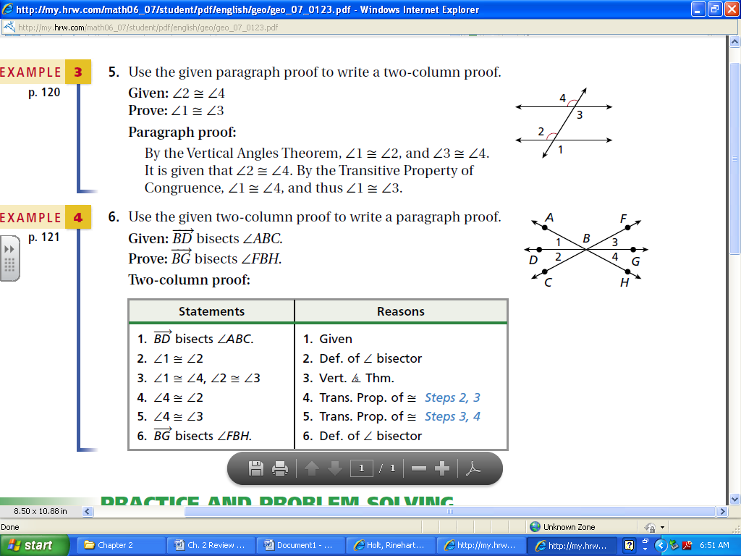

1. 
2. 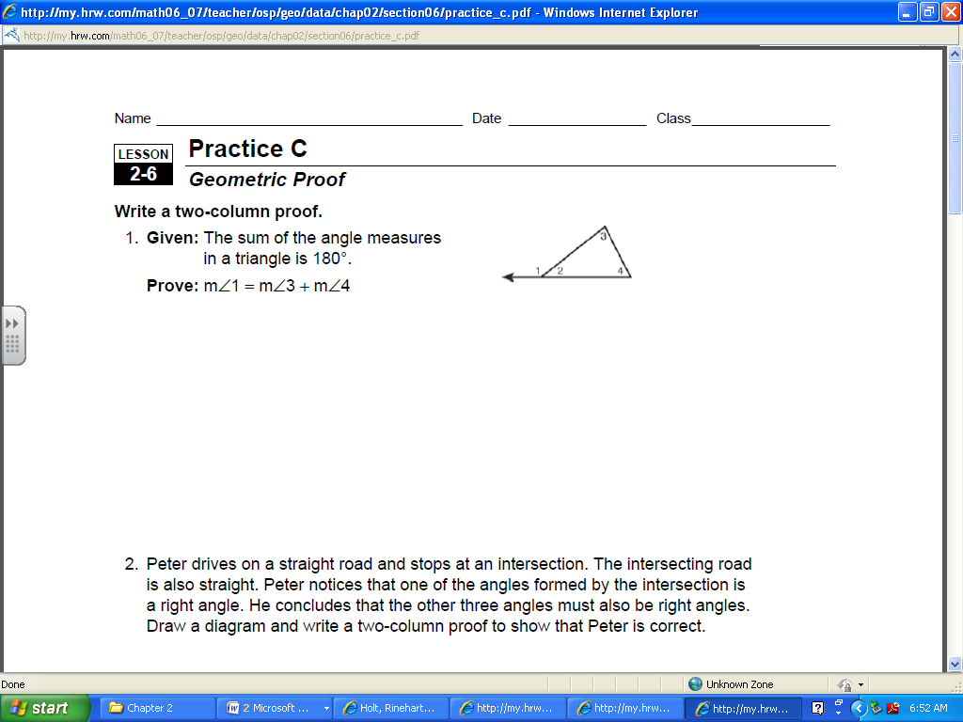
3. 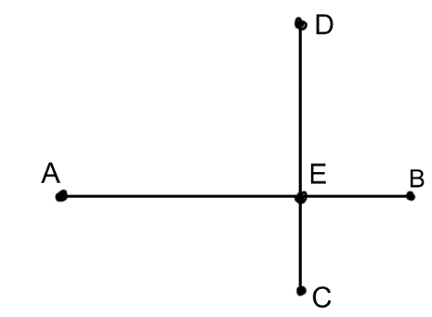Given: $\overline{BE}≅\overline{CE}$ and $\overline{DE}≅\overline{AE}$

Prove: $\overline{AB}≅\overline{CD}$

1. 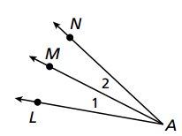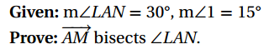
2. 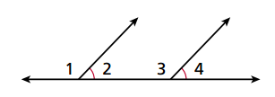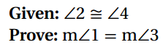

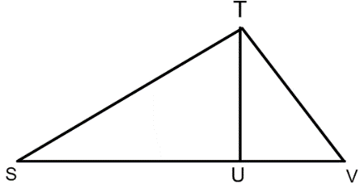

1. Given: $\overline{TU}≅\overline{UV}$

Prove: SU + TU = SV

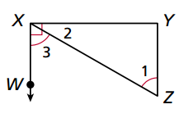

1. 
2. 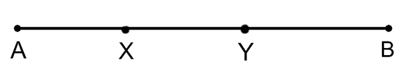Given: X is the midpoint of $\overline{AY}$

Y is the midpoint of $\overline{XB}$

Prove: $\overline{AX}≅\overline{YB}$