1. Write a justification for each step. Given: . .

Prove and are supplementary.

|  |  |
| --- | --- |
| Statements | Reasons |
| , | 1. |
|  | 2. |
|  | 3. |
|  | 4.Addition POE |
|  | 5. |
| and are supplementary | 6. |

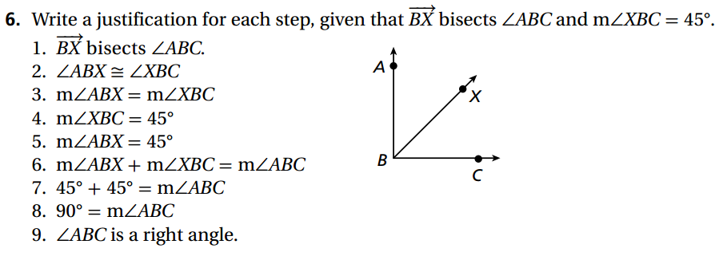

1. Write a justification for each step. Given:  bisects . . Prove:  is a right angle.

|  |  |
| --- | --- |
| Statement | Reason |
| bisects | 1. |
|  | 2. |
|  | 3. |
|  | 4. |
|  | 5. |
|  | 6. |
|  | 7. |
|  | 8. |
| is a right angle | 9. |

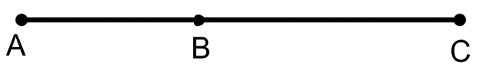

1. Given: AB = 2x, BC =5, AC = 9

Prove: x = 2

|  |  |
| --- | --- |
| **Statement** | **Reason** |
|  |  |

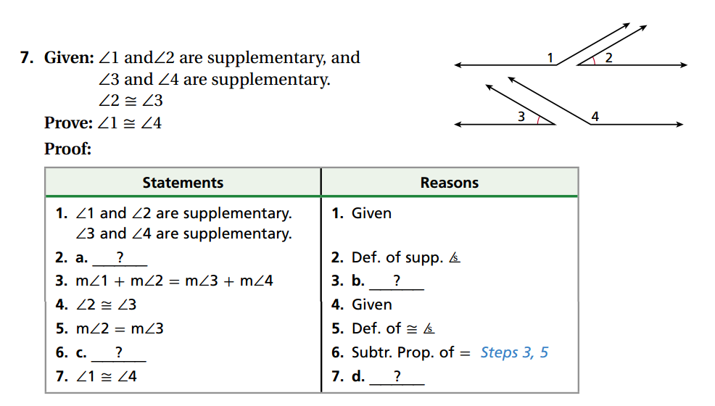

|  |  |
| --- | --- |
| Statement | Reason |
| and are supplementary  and are supplementary | Given |
| a. | Definition of Supplementary Angles |
|  | b. |
|  | Given |
|  | Definition of Congruence |
|  | c. |
|  | d. |
|  | e. |

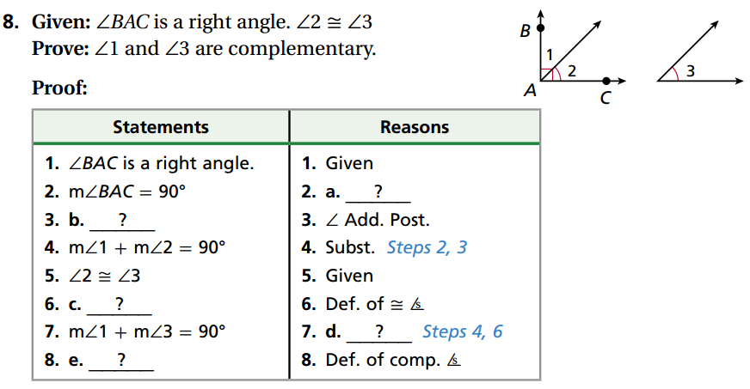

1. Given: is a right angle. 

Prove: and are complementary

|  |  |
| --- | --- |
| Statement | Reason |
| is a right angle | Given |
|  | a. |
| b. | Angle Addition Postulate (Look at the picture) |
|  | Substitution |
|  | Given |
| c. | Definition of Congruent Angles |
|  | d. |
| e. | Definition of Complementary Angles |

1. Given:  and  are complementary angles. 

Prove: 

|  |  |
| --- | --- |
| Statement | Reason |
|  |  |

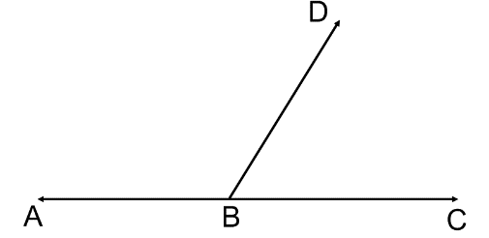

1. Given: 

Prove: $m∠DBC=60°$

|  |  |
| --- | --- |
| **Statement** | **Reason** |
|  |  |

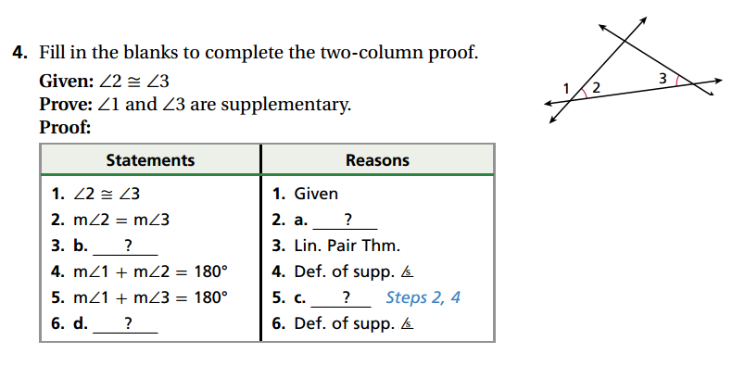

1. Given: $∠2≅∠3$

Prove: $∠1 and ∠3$ are supplementary

|  |  |
| --- | --- |
| Statement | Reason |
|  | Given |
|  | a. |
| b. | Linear Pair Postulate |
|  | c. |
|  | d. |
| e. | Definition of Supplementary Angles |

1. 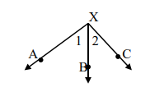Given: $∠1 and ∠2$ are complementary.

Prove: $\vec{XA} ⊥\vec{XC}$

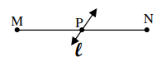

1. Given: $line l$ bisects MN at P

Prove: $MP = PN$

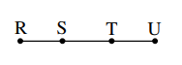

1. Given: $\overline{RT}≅ \overline{SU}$

Prove: $RS = TU$