WS – Geometric Proof 1
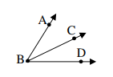
- Given: $m∠ABC = m∠CBD$
Prove: $\vec{BC}$is the angle bisector of $∠ABD$

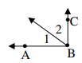
- Given: $∠ABC$ is a right angle
Prove: $∠1$ and $∠$2 are complementary

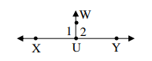
- Given: $m∠1=90°$
Prove: $m∠2=90°$

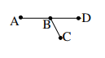
- Given: $AB = BC, BC = BD$
Prove: $B$ is the midpoint of $AD$

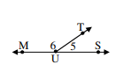
- Given: $m∠5=47°$
Prove: $m∠6=133°$

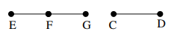
- Given: $\overline{CD} ≅ \overline{EF}, \overline{CD} ≅ \overline{FG}$
Prove: $F$ is the midpoint of $\overline{EG}$

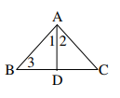
- Given: $\overline{AD} bisects ∠BAC, ∠1≅ ∠3$
Prove: $∠2≅∠3$

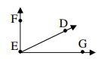
- Given: $\overline{EF} ⊥ \overline{EG}$, $D$ is in the interior of $∠FEG$
Prove: $∠FED and ∠DEG$are complementary

